Integrating the Healthcare Enterprise



IHE PCC

Technical Framework Supplement

Perinatal Workflow (PWF)

Draft for Public Comment

Date: January 28, 2010
Author: Keith W. Boone
Email: keith.boone@ge.com
Foreword
This is a supplement to the IHE PCC Technical Framework <VX.X>. Each supplement undergoes a process of public comment and trial implementation before being incorporated into the volumes of the Technical Frameworks.
[For Public Comment: This supplement is submitted for Public Comment between <Month XX, 201X and Month XX, 201X >. Comments are invited and may be submitted to the IHE forums at < http://forums.rsna.org publisher will fill in full url>. In order to be considered in development of the Trial Implementation version of the supplement comments must be received by <Month XX, 201X>. Please use the Public Comment Template provided in the thread and submit comments by posting the completed template as an attachment to a Reply or New Thread.]
[For Trial Implementation: This supplement is submitted for Trial Implementation as of <Month XX, 201X> and will be available for testing at subsequent IHE Connectathons. The supplement may be amended based on the results of testing. Following successful testing it will be incorporated into the PCC Technical Framework. Comments are invited and may be submitted on the IHE forums at< http://forums.rsna.org publisher will fill in full url> or by email to <domain_name@ihe.net>.]
This supplement describes changes to the existing technical framework documents and where indicated amends text by addition (bold underline) or removal (bold strikethrough), as well as addition of large new sections introduced by editor’s instructions to “add new text” or similar, which for readability are not bolded or underlined.
“Boxed” instructions like the sample below indicate to the Volume Editor how to integrate the relevant section(s) into the relevant Technical Framework volume:

Replace Section X.X by the following:

General information about IHE can be found at: www.ihe.net
Information about the IHE PCC may be found at: http://www.ihe.net/Domains/index.cfm
Information about the structure of IHE Technical Frameworks and Supplements can be found at: http://www.ihe.net/About/process.cfm and http://www.ihe.net/profiles/index.cfm
The current version of the IHE Technical Framework can be found at: http://www.ihe.net/Technical_Framework/index.cfm

CONTENTS
Introduction 3
Profile Abstract 3
Open Issues and Questions 3
Closed Issues 3
Volume 1 – Integration Profiles 4
1.7 History of Annual Changes 4
1.n Copyright Permission 4
2.1 Dependencies among Integration Profiles 4
2.2.X Perinatal Workflow (PWF) Integration Profile 6
X Perinatal Workflow (PWF) Integration Profile 6
X.1 Actors/ Transactions 6
X.2 Perinatal Workflow (PWF) Integration Profile Options 9
X.3 Perinatal Workflow (PWF) Process Flow 9
X.4 Perinatal Workflow (PWF) Security Considerations 13
<Appendix A> Actor Summary Definitions 13
<Appendix B> Transaction Summary Definitions 13
Glossary 14
Volume 2 - Transactions 15
3.Y <Transaction Name> 15
3.Y.1 Scope 15
3.Y.2 Use Case Roles 15
3.Y.3 Referenced Standard 15
3.Y.4 Interaction Diagram 15
<Appendix letter> Appendix_Name Error! Bookmark not defined.

Introduction
This profile principally updates Volume I of the IHE PCC Technical Framework and references transactions, content profiles and Actors from other IHE domains, including laboratory, radiology and IT Infrastructure.

Profile Abstract
Perinatal workflows are fairly complex, involving communication between ambulatory providers, laboratories, imaging enabled facilities and labor and delivery centers. The Perinatal Workflow profile simplifies exchanges between these various providers of care by utilizing profiles and transactions from several IHE domains to support the continuum of care of expectant mothers and newborns.

Open Issues and Questions
- It isn’t clear which transaction should be used for ADT. Should it be ITI-15 (PIX), ITI-30 (PAM), LAB-1 (LTW) or RAD-1 (SWF) or some combination thereof. I would recommend PAM.
- The Section Import Option is rarely used, should it be referenced as an option for this profile?
- How do we handle exchange of content. Should their be options supporting topology, or should their be a required grouping with actors from XDS, XDR and XDM. I would recommend the latter.
- Should PCC-0 require use of PIX/PDQ at least once per patient (as we have been demonstrating annually for the last 5 years)?
- What do we do about patient monitoring in the Labor and Delivery center (e.g., Holter).
- Still need to address folders.
- Do we need to address care prior to conception (e.g., fertility treatment) in the perinatal episode of care? MM: Add on at a future point…, surrogates…, AD: More of an issue, but agrees that it can be an add-on, LH: Yes, but as an add-on for future. Not within current scope. KB: Not been addressed in a profile, let’s leave out of scope. TS: Identify the use case for future work. LH: Where do we call it out, vs, do the work.
- Vital Records may need to be addressed.

Closed Issues

Volume 1 – Integration Profiles

1.7 History of Annual Changes
<Brief overview of “what’s new” in the given year of the Technical Framework.>
Add the following bullet to the end of the bullet list in section 1.7
- Added the Perinatal Workflow (PWF) profile to simplify exchanges between various providers of perinatal care utilizing profiles and transactions from several IHE domains to support the continuum of care of expectant mothers and newborns.

1.n Copyright Permission
<Add information on any standards referenced in the profile that are not already addressed in the permission section.>
Add the following to sections 1.n:

2.1 Dependencies among Integration Profiles
Add the following to Table 2-1

PWF | CT | <?> | <->
PWF | ATNA
PWF | APS | A Care Manager implementing the Obstetric Option must demonstrate the ability to be a Content Creator of the Antepartum Summary (APS) Profile. All Care Managers must demonstrate the ability to implement the View Option of the Content Consumer of the APS profile.
PWF | APHP | A Care Manager implementing the Obstetric Option must demonstrate the ability to be a Content Creator of the Antepartum History and Physical. All Care Managers must demonstrate the ability to implement the View Option of the Content Consumer for the APHP profile.
PWF | APE | All Care Managers must demonstrate the ability to implement the View Option of the Content Consumer for the Antepartum Education Profile
PWF | APL | All Care Managers must demonstrate the ability to implement the View Option of the Content Consumer for the Antepartum Lab profile.
PWF | PPVS | A Care Manager implementing the Obstetric Option must demonstrate the ability to be a Content Creator of the Post Partum Visit Summary (PPVS). All Care Managers must demonstrate the ability to implement the View Option of the Content Consumer for the PPVS profile.
PWF | LDHP | A Care Manager implementing the Labor and Delivery Option must demonstrate the ability to be a Content Creator of the Labor and Delivery History and Physical (LDHP). All Care Managers must demonstrate the ability to implement the View Option of the Content Consumer for the LDHP profile.
PWF | LDS | A Care Manager implementing the Labor and Delivery Option must demonstrate the ability to be a Content Creator of the Labor and Delivery Summary (LDS). All Care Managers must demonstrate the ability to implement the View Option of the Content Consumer of the LDS profile.
PWF | MDS | A Care Manager implementing the Labor and Delivery Option must demonstrate the ability to be a Content Creator of the Maternal Discharge Summary (MDS). All Care Managers must demonstrate the ability to implement the View Option of the Content Consumer of the MDS prifle.
PWF | NDS | A Care Manager implementing the Labor and Delivery Option must demonstrate the ability to be a Content Creator of the Newborn Discharge Summary (NDS). All Care Managers must demonstrate the ability to implement the View option of the Content Consumer of the NDS profile.

Add the following section to section 2.2

2.2.X Perinatal Workflow (PWF) Integration Profile
Perinatal workflows are fairly complex, involving communication between ambulatory providers, laboratories, imaging enabled facilities and labor and delivery centers. The Perinatal Workflow profile simplifies exchanges between these various providers of care by utilizing profiles and transactions from several IHE domains to support the continuum of care of expectant mothers and newborns.

Add Section X

X Perinatal Workflow (PWF) Integration Profile
Perinatal workflows are fairly complex, involving communication between ambulatory providers, laboratories, imaging enabled facilities and labor and delivery centers. The Perinatal Workflow profile simplifies exchanges between these various providers of care by utilizing profiles and transactions from several IHE domains to support the continuum of care of the expectant mother and their soon to be newborn children.
The period of perinatal care constitutes an episode of care that covers the period from conception through delivery of the newborn and finishes at the final postpartum visit. This episode of care is further subdivided into the antepartum period (from conception to delivery, labor and delivery, and post-partum (from delivery to the final post partum visit).

X.1 Actors/ Transactions
Figure X.1-1 shows the actors directly involved in the Perinatal Workflow (PWF) Integration Profile and the relevant transactions between them. Other actors that may be indirectly involved due to their participation in other related profiles are not necessarily shown.
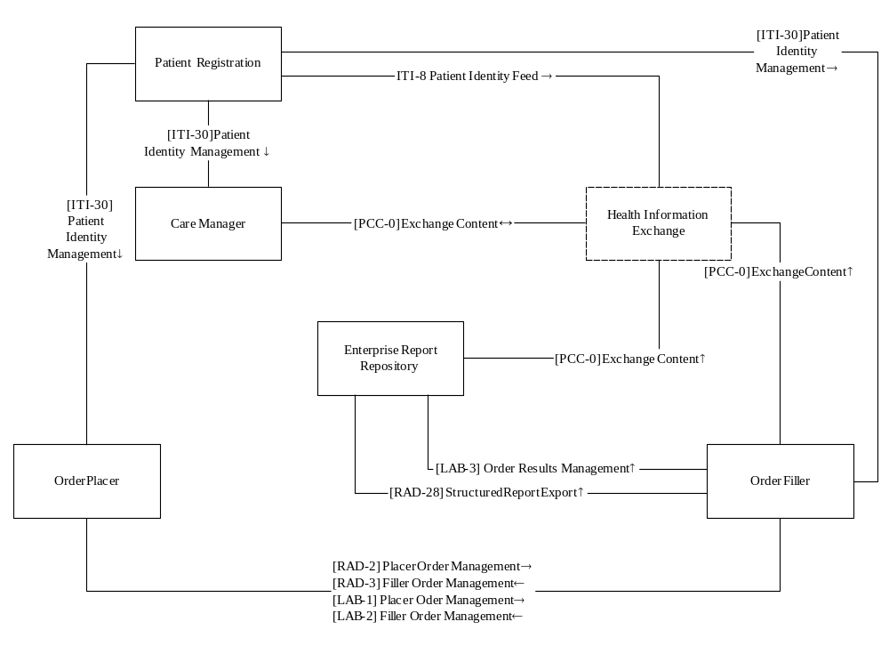
Figure X.1-1. Perinatal Workflow (PWF) Actor Diagram
Table X.1-1 lists the transactions for each actor directly involved in the Perinatal Workflow (PWF) Profile. In order to claim support of this Integration Profile, an implementation must perform the required transactions (labeled “R”). Transactions labeled “O” are optional. A complete list of options defined by this Integration Profile and that implementations may choose to support is listed in Volume I, Section X.2.

Table X.1-1. Perinatal Workflow (PWF) Integration Profile - Actors and Transactions
Actors | Transactions | Opt | Section in Vol. 2
Patient Registration | ITI-8 Patient Identity Feed | R | ITI TF-2:3.8
Patient Registration | ITI-30 Patient Identity Management | R | ITI TF-2:3.30
Care Manager | PCC-0 Exchange Content | R | PCC TF-2:3.0
Care Manager | APS Antepartum Summary | C⁵ | PCC APR:W
Care Manager | APHP Antepartum History and Physical | C⁵ | PCC APR:X
Care Manager | APE Antepartum Education | C⁴ | PCC APR:Y
Care Manager | APL Antepartum Laboratory | C⁴ | PCC APR:Z
Care Manager | PPVS Post Partum Visit Summary | C⁴ | PCC PPVS
Care Manager | LDHP Labory and Delivery History and Physical | C⁶ | PCC APR:A
Care Manager | LDS Labor and Delivery Summary | C⁶ | PCC APR:B
Care Manager | LDS Maternal Discharge Summary | C⁶ | PCC APR:C
Care Manager | XDS-SD Scanned Documents | C⁴ | ITI TF-3:5.2
Care Manager | XD-LAB Sharing Laboratory Reports | C⁴ | LAB TF-3:2
Care Manager | ITI-30 Patient Identity Management | C³ | ITI TF-2:3.30
Health Information Exchange | PCC-0 Exchange Content | R | PCC TF-2:3.0
Health Information Exchange | ITI-8 Patient Identity Feed | R | ITI TF-2:3.8
Order Placer | ITI-30 Patient Identity Management | C³ | ITI TF-2:3.30
Order Placer | RAD-2 Placer Order Management | R | RAD TF-2:4.2
Order Placer | RAD-3 Filler Order Management | R | RAD TF-2:4.3
Order Placer | LAB-1 Placer Order Management | R | LAB TF-2:4.1
Order Placer | LAB-2 Filler Order Management | R | LAB TF-2:4.2
Order Filler | ITI-30 Patient Identity Management | C³ | ITI TF-2:3.30
Order Filler | RAD-2 Placer Order Management | C¹ | RAD TF-2:4.2
Order Filler | RAD-3 Filler Order Management | C¹ | RAD TF-2:4.3
Order Filler | RAD-28 Structured Report Export | C¹ | RAD TF-2:4.28
Order Filler | LAB-1 Placer Order Management | C² | LAB TF-2:4.1
Order Filler | LAB-2 Filler Order Management | C² | LAB TF-2:4.2
Order Filler | LAB-3 Order Results Management | C² | LAB TF-2:4.3
Order Filler | PCC-0 Exchange Content | C⁷ | PCC TF-2:3.0
Order Filler | XD-LAB Sharing Laboratory Reports | C⁸ | LAB TF-3:2
Order Filler | XDS-SD Scanned Documents | C⁹ | ITI TF-3:5.2
Enterprise Report Repository | RAD-28 Structured Report Export | R | RAD TF-2:4.28
Enterprise Report Repository | LAB-3 Order Results Management | R | LAB TF-2:4.3
Enterprise Report Repository | PCC-0 Exchange Content | R | PCC TF-2:3.0
Enterprise Report Repository | XD-LAB Sharing Laboratory Reports | R | LAB TF-3:2
Enterprise Report Repository | XDS-SD Scanned Documents | R | ITI TF-3:5.2
Note 1: Required if the Actor implements the Imaging Option
Note 2: Required if the Actor implements the Laboratory Option
Note 3: Required if the Actor implements the Patient Registration Option
Note 4: Care Managers are required to implement the View Option of the Content Consumer for these content profiles.
Note 5: Care Managers implementing the Obstetrics Option are required implement the Content Creator for these content profiles.
Note 6: Care Managers implementing the Labor and Delivery Option are required implement the Content Creator for these content profiles.
Note 7: Order Fillers implementing the Content Creator Option are required to create an XDS-SD or XD-LAB depending up whether the implement the Imaging or Laboratory Option.
Note 8: An Order Filler implementing the Content Creator Option and the Laboratory Option is required to implement the Content Creator actor of the XD-LAB profile.
Note 9: An Order Filler implementing the Content Creator Option and the Imaging Option is required to implement the Content Creator actor of the XDS-SD profile.

X.2 Perinatal Workflow (PWF) Integration Profile Options
Options that may be selected for this Integration Profile are listed in the table X.2-1 along with the Actors to which they apply. Dependencies between options when applicable are specified in notes.
Table X.2-1 Perinatal Workflow (PWF) - Actors and Options
Actor | Options | Vol & Section
Patient Registration | No options defined | - -
Care Manager | Document Import Option  Discrete Data Import Option  Patient Registration Option  Obstetrics Option  Labor and Delivery Option | PCC TF-2:3.0.2  PCC TF-2:3.0.4
Health Information Exchange | No options defined | - -
Order Placer | Patient Registration Option
Order Filler | Patient Registration Option  Imaging Option¹  Laboratory Option¹  Content Creator Option
Enterprise Report Repository | No options defined

Note 1: At least one of these options shall be specified.

X.2.4 Patient Registration Option
An actor implementing the Patient Registration option must implement transaction ITI-30 Patient Identity Management. A system that passes the tests for the Patient Demographics Consumer Actor as described in the IHE ITI Patient Administration Management (PAM) profile has successfully demonstrated implementation of this option.

X.2.5 Obstetrics Option
A Care Manager actor that implements the Obstetrics Option is intended for use in that setting and is capable of creating the necessary content that is shared from an Ob/Gyn setting to a labor and delivery setting. A system that passes tests for the Content Creator Actors defined for the Antepartum Summary (APS) and Antepartum History and Physical (APHP) content profiles has successfully demonstrated implementation of this option.

X.2.6 Labor and Delivery Option
A Care Manager actor that implements the Labor and Delivery Option is intended for use in that setting. It is capable of supporting patient registration and is therefore required to implement the Patient Registration Option as well. It is also capable of creating the necessary content that is shared from an labor and delivery setting to an Ob/Gyn setting. A system that passes tests for the Content Creator Actors defined for the Labor and Delivery History and Physical (LDHP), Labor and Delivery Summary (LDS) and Maternal Discharge Summary (MDS) has successfully demonstrated implementation of this option.

X.2.7 Imaging Option
An Order Filler that implements imaging option must implement transactions RAD-2 Placer Order Management, RAD-3 Filler Order Management and RAD-28 Structured Report Export. Futhermore, if it implements the Content Creator Option it must also implement the Content Creator Actor of the XDS-SD profile.

X.2.8 Laboratory Option
An Order Filler that implements laboratory option must implement transactions LAB-1 Placer Order Management, LAB-2 Filler Order Management and LAB-3 Order Results Management. Futhermore, if it implements the Content Creator Option it must also implement the Content Creator Actor of the XD-LAB profile.

X.2.9 Content Creator Option
An order filler implementing the Content Creator option demonstrates that it can exchange the result of that order with other systems (e.g., through a Health Information Exchange).

X.3 Perinatal Workflow (PWF) Process Flow
Figure X.3-1 below shows the basic flows expected in the Perinatal Workflow profile. The registration actor performs registration and updates of patient information. These updates can be sent to the Care Manager, Order Placer, Order Filler or Health Information Exchange.
During the initial obstetric visit the provider will create a clinical documents using the Antepartum History and Physical.
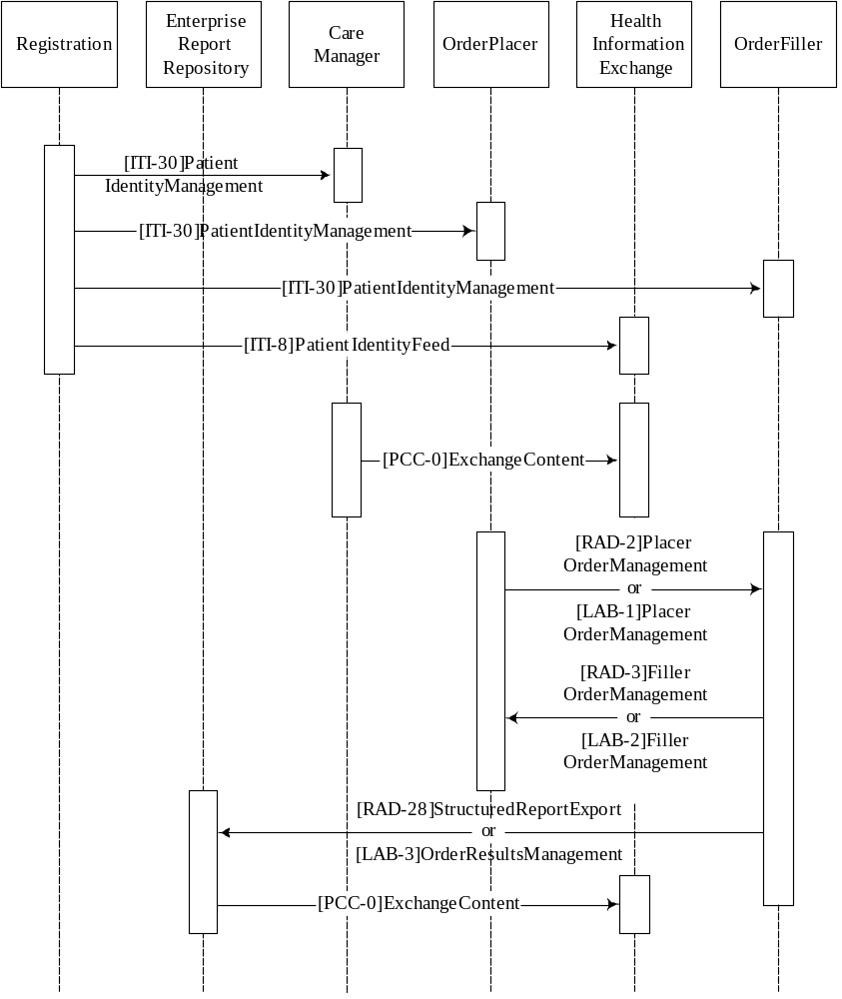
Figure X.3-1. Basic Process Flow in Perinatal Workflow (PWF) Profile

X.4 Perinatal Workflow (PWF) Security Considerations
<Description of the Profile specific security considerations. This should include the outcomes of a risk assessment. This likely will include profile groupings, and residual risks that need to be assigned to the product design, system administration, or policy.>
<Appendix A> Actor Summary Definitions
Registration
Enterprise Report Repository
Order Placer
Order Filler
Health Information Exchange
<Appendix B> Transaction Summary Definitions
Exchange Content

Glossary
Add the following terms to the Glossary:
<any glossary additions associated with the profile draft go here>

Volume 2 - Transactions
Add section 3.Y

3.0 Exchange Content
This section corresponds to Transaction 0 of the IHE PCC Technical Framework. Transaction Y is used by the Content Creator and Content Consumer actors of various IHE Content profiles.

3.Y.1 Scope

3.Y.2 Use Case Roles
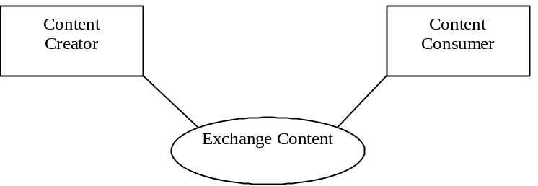

Actor: Content Creator
Role: Create Content
Actor: Content Consumer
Role: View or Import Content

3.Y.3 Referenced Standard
IHE XDS, XDR or XDM Profile

3.Y.4 Interaction Diagram
PIX or PDQ Transaction [If XDS]
XDS (PIX/PDQ, Stored Query, Document Retrieve and View or Import, XDR or XDM transaction(s)
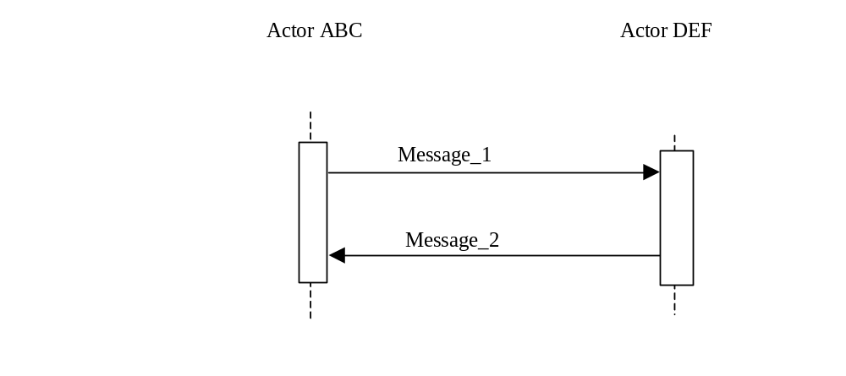

3.Y.4.1 <Message_1 Name>
<One or two sentence description of the first message of the above interaction diagram, typically relating the message to the relevant standard>

3.Y.4.1.1 Trigger Events
<description of the real world events that cause the initiation of the first message>

3.Y.4.1.2 Message Semantics
<detailed description of the meaning, structure and contents of the first message including any IHE specific clarifications of the message format, attributes, etc.>

3.Y.4.1.3 Expected Actions
<description of the actions expected to be taken as a result of sending or receiving this message>

3.Y.4.2 <Message_2 Name>
<One or two sentence description of the the next message in the above interaction diagram, typically relating the message to the relevant standard. Note, repeat this section as necessary based on the number of messages in the interaction diagram>

3.Y.4.2.1 Trigger Events
<description of the real world events that cause the initiation of the next message>

3.Y.4.2.2 Message Semantics
<detailed description of the meaning, structure and contents of the next message including any IHE specific clarifications of the message format, attributes, etc.>

3.Y.4.2.3 Expected Actions
<description of the actions expected to be taken as a result of sending or receiving this message>

3.0.5 Security Considerations
<description of the transaction specific security consideration. Such as use of security profiles. >
Use of ATNA as required by XDS/XDR.
Use of CT for all actors.

3.0.5.1 Security Audit Considerations
Audit as Per PIX, PDQ, XDS, XDR or XDM profiles.

3.0.5.1.(z) Actor Specific Security Considerations
On Print through the application, the application shall generate the appropriate AUDIT message. The View Option shall display patient demographics in each view window.

